NAME: BANDANA PACHABHAIYA MAGAR

ID: C0916126

**Question 1:** Write SQL query that displays the last name and salary of employees earning more than $12,000.

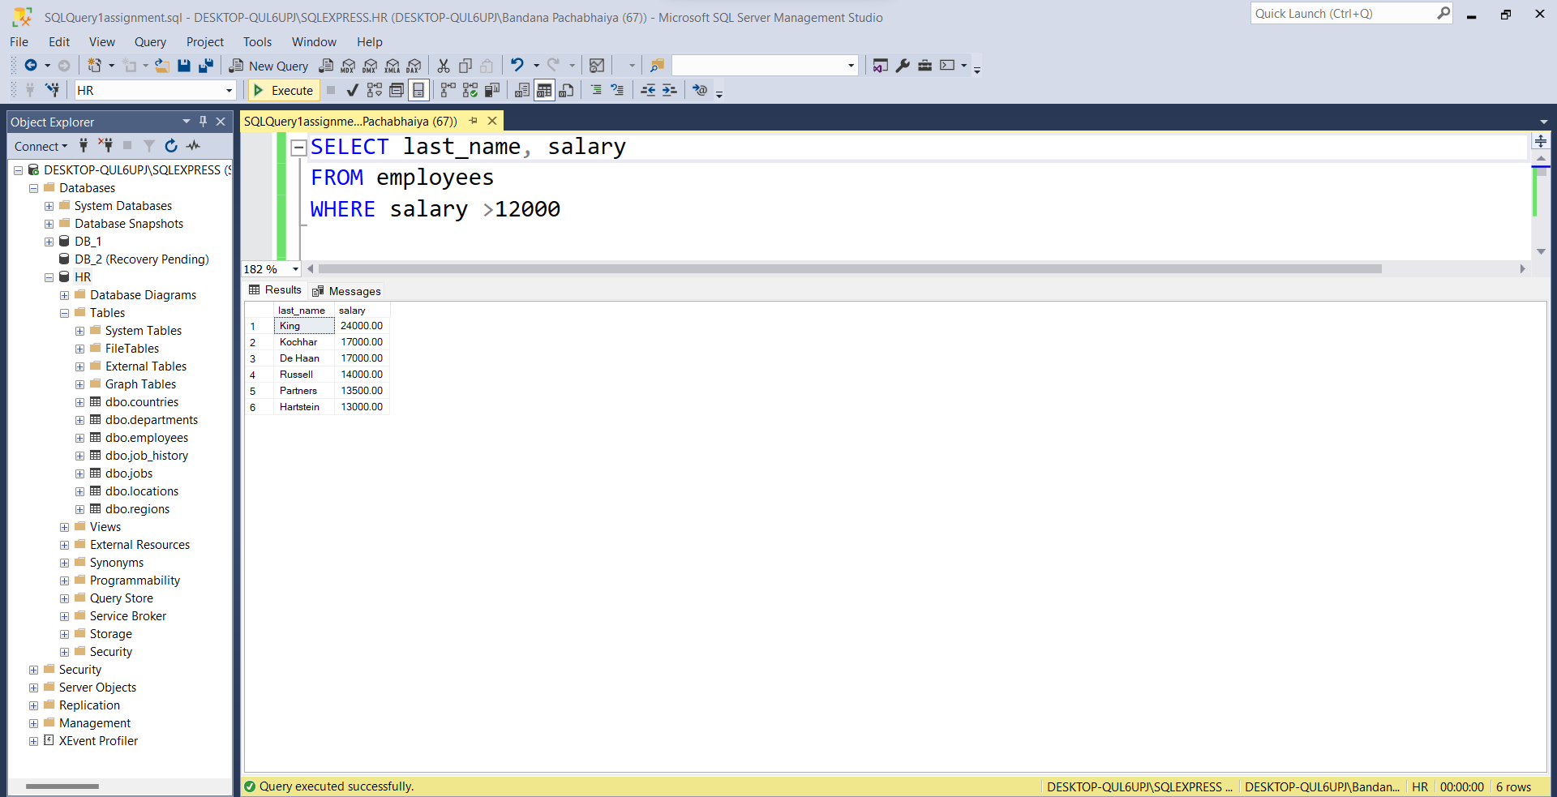

**Question 2:** Write SQL query to display the last name and salary for all employees whose salary is not in the range $5,000 (exclusive) through $12,000 (exclusive)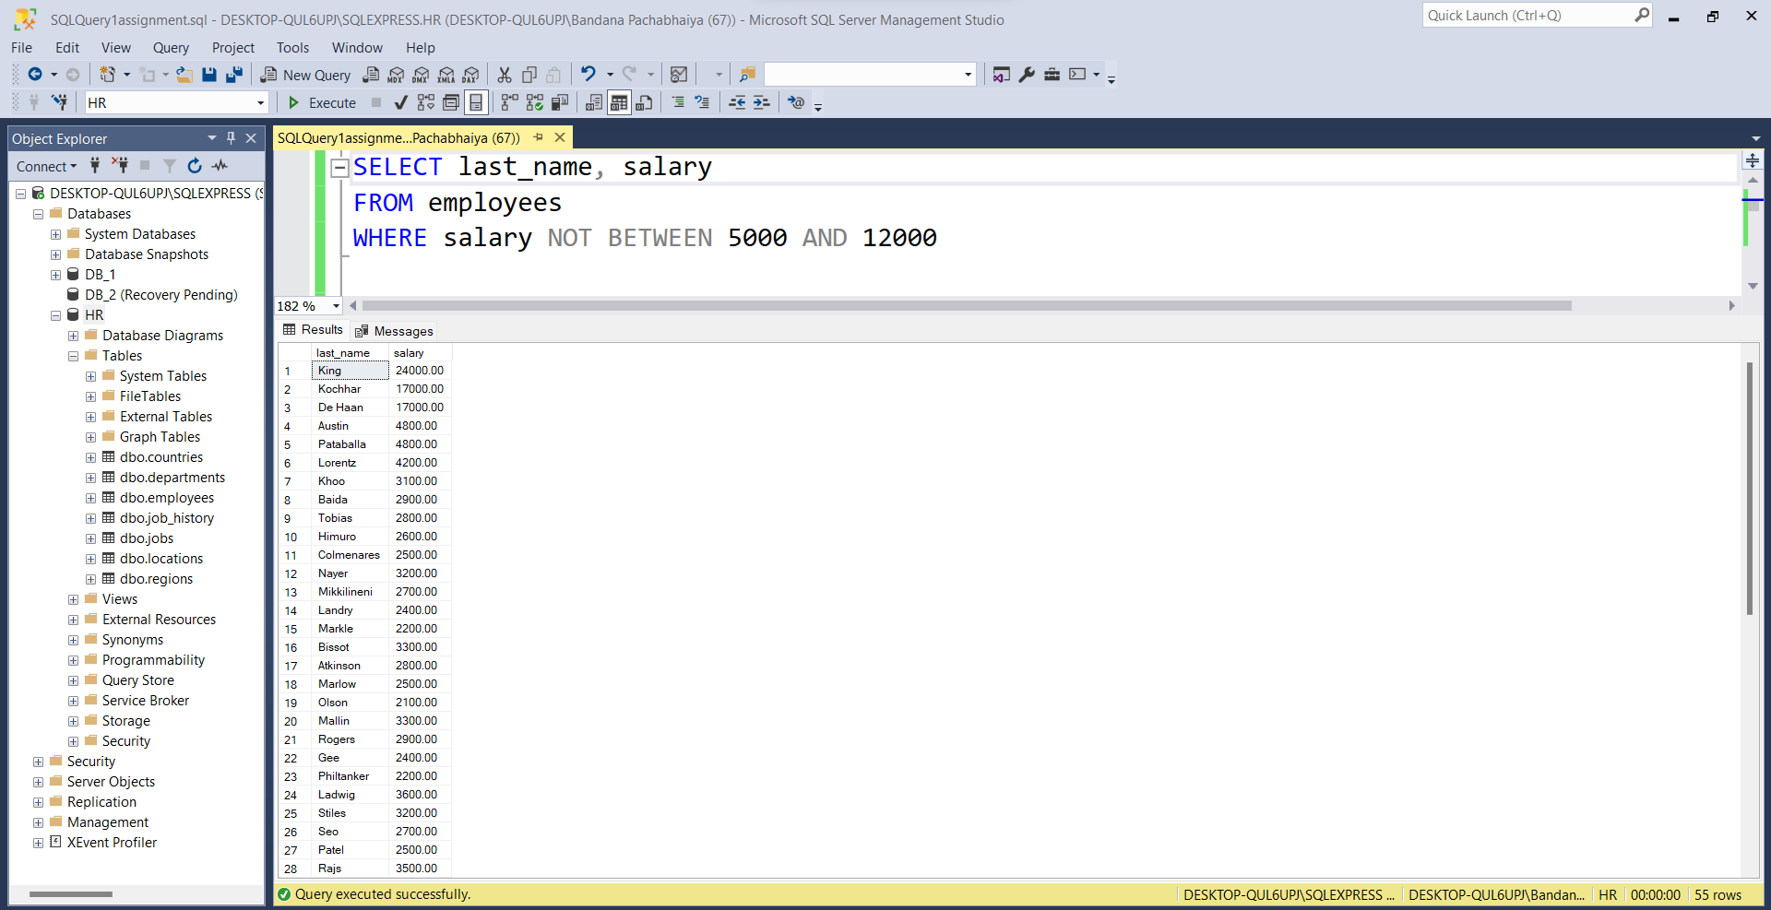

**Question 3:** Write SQL query to display the last name, job ID, and hire date for employees with the last names of Matos and Taylor. Order the query in ascending order by hire date.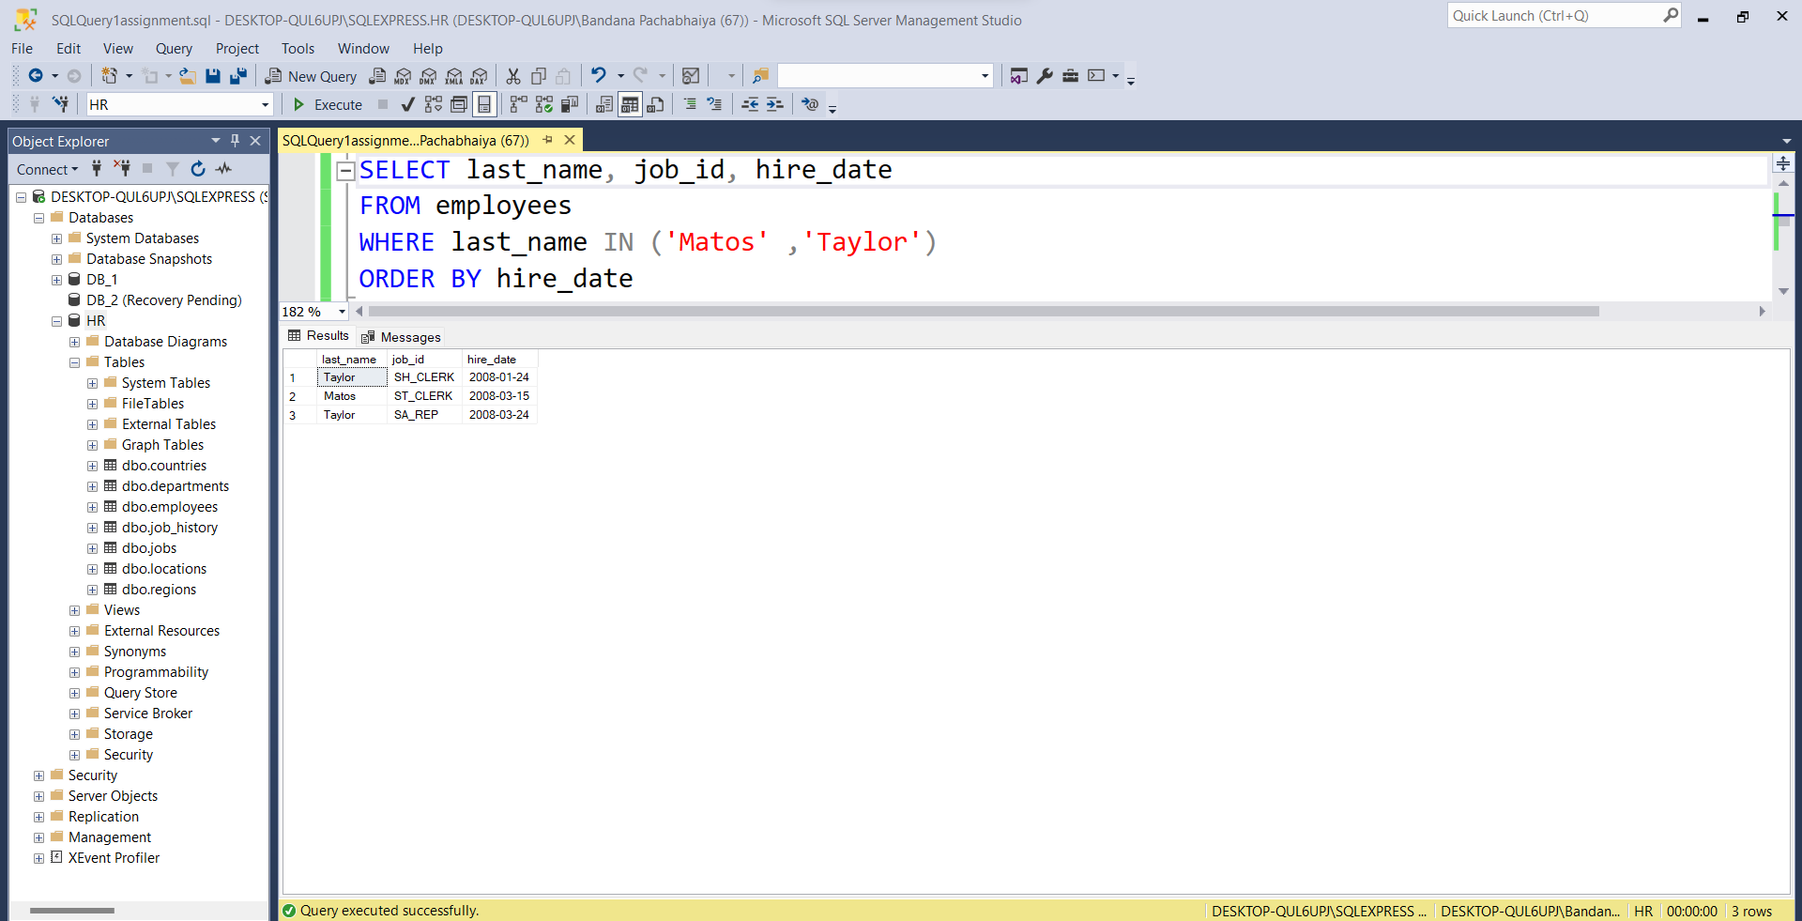

**Question 4:** Write a query that displays the last names of all employees who have both an “a” and an “e” in their last name.

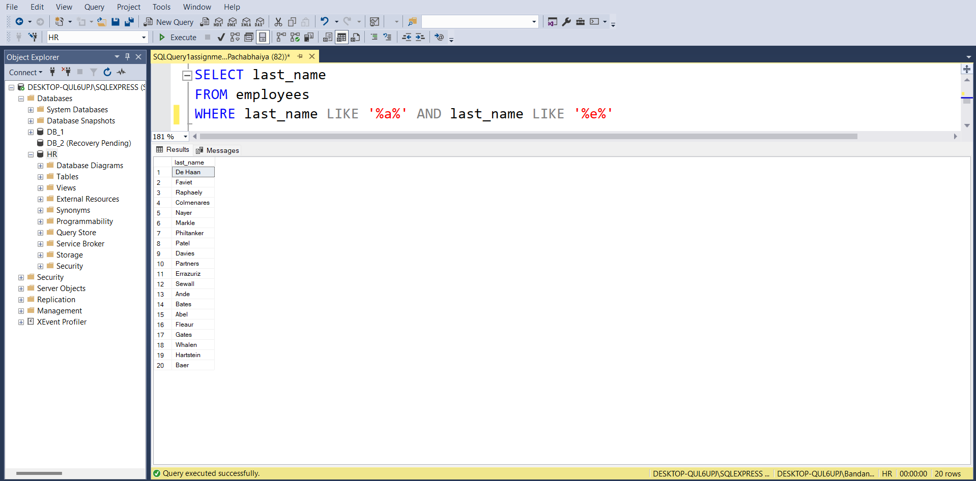

**Question 5:** Write a query to display the employee number, last name, salary, and salary increased by 11.5% (expressed as a whole number) for each employee. Label the column New Salary. 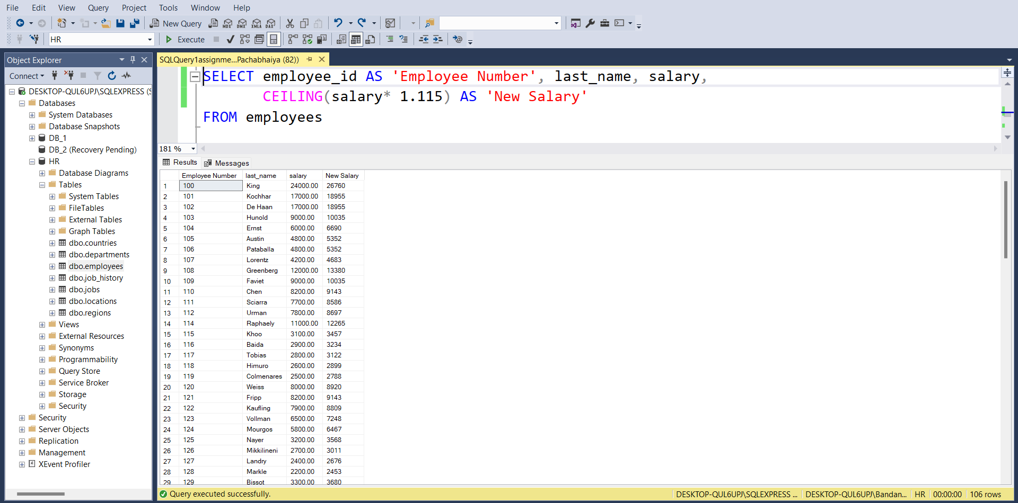

**Question 6:** Write a query that display the list of department codes, and the maximum, minimum and the average salary in each department, sorted by maximum salary

